2001 Panorama Drive
Port Moody, BC V3H 5G8
Tel: 604 461 7680 Fax: 604 461 7615
aspenwood@sd43.bc.ca

Just a few items to note as we race to the finish line of this school year…

LAST DAY OF SCHOOL
School will be in session on Thursday, June 25th for the day. Teachers will be planning a variety of activities for the students to enjoy. Please be sure to let the office know if your child will not be in attendance.

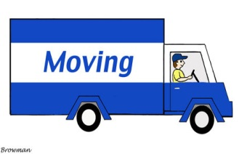
Aspenwood Yearbooks will be handed out to students who ordered them on Wednesday, June 24th

ARE YOU MOVING?
If you are moving, please let the office know as soon as possible.

CONTACT INFORMATION
Please let the office know if your contact information is changing over the summer. On occasion, we send out emails over the summer and so it is important to ensure that the office has your most recent contact information.

REPORT CARDS
Report cards will be handed out to students on Thursday, June 25th. If your child will not be in attendance and wish to have the report card mailed, please provide the office with a self-addressed, stamped envelope for mailing, or reports can be picked up at the office until Friday, July 3rd and then after August 31st.

Laurie Birnie,
Principal,

